AI News Avatar Pipeline – Technical Report

Candidate: Mahnoor Arif
Project Title: End-to-End AI News Avatar Pipeline
Date: February 2026

- Introduction
This project presents an end-to-end automated system that transforms raw online news articles into a professional, AI-generated video news broadcast. The pipeline integrates web scraping, Large Language Model (LLM)–based summarization, script generation, and AI avatar video synthesis into a unified, production-ready application exposed via a FastAPI backend.
The primary objective of this system is to demonstrate practical AI engineering skills, including API integration, prompt engineering, asynchronous processing, and modular system design.

- System Overview
The pipeline follows a linear but modular workflow:
- News Extraction – Scraping reputable online news sources
- LLM Summarization – Generating concise, factual summaries
- Script Generation – Producing a broadcast-style news script
- Avatar Video Synthesis – Rendering a lip-synced AI news anchor video
- API Interface – Managing execution and monitoring via FastAPI
The system is designed for extensibility, allowing each component to be replaced or scaled independently.

3. Architecture & Components
3.1. Data Ingestion Layer (News Scraping)
Objective:
Collect recent news articles and normalize them into structured textual data.
Implementation Details:
- Uses Requests for HTTP fetching and newspaper3k for HTML parsing
- Targets reputable public news sources
- Extracts:
  - Article headline
  - Cleaned article body (HTML boilerplate removed)
  - Source URL for traceability
Output:
A structured JSON object containing validated news articles ready for NLP processing.
3.2 LLM-Based Summarization
Objective:
Condense long-form news articles into concise, neutral, and factual summaries.
Implementation Details:
- Each article is processed independently to prevent cross-article contamination
- Uses OpenAI / Gemini LLM APIs
- Prompt constraints enforce:
  - Factual correctness
  - Neutral tone
  - No hallucinated or speculative information
- Each article is summarized into 3–4 sentences
- Metadata (title and URL) is preserved for traceability
Output:
High-quality summaries that capture the essential information from each article.

3.3 Script Generation
Objective:
Transform multiple summaries into a single coherent, professional news-anchor script.
Prompt Strategy:
- The LLM is assigned the role of a professional TV news anchor
- Enforced constraints:
  - Broadcast-appropriate tone
  - Clear introduction and closing
  - Each news item mentioned exactly once
  - Conversational but neutral delivery
Timing Control:
To meet the 30–45 second requirement, script length is constrained using a time-based formula:
$$\text{Target Words}=\frac{\text{Target Seconds}×\text{Words Per Minute}}{60}$$
- Speaking rate: 140–160 WPM
- Resulting script length: 75–110 words
Output:
A finalized, speech-optimized news script ready for video synthesis.

3.4 Avatar Video Generation
Objective:
Render a realistic, lip-synced AI avatar video delivering the generated news script.
Implementation Details:
- Integrates with a third-party avatar service (D-ID)
- Authentication handled securely via environment variables
- Request payload includes:
  - Final news script
  - Neural text-to-speech voice configuration
  - Professional presenter avatar
  - Fluent lip-sync and facial animation settings
- Video rendering is asynchronous
- A polling mechanism tracks render progress until completion
Output:
- Unique video generation ID
- Rendering status
- Downloadable 1080p MP4 video URL

  - Backend API Design
The backend is implemented using FastAPI and is accessible via Swagger UI (/docs), enabling easy evaluation and testing.
Key Endpoints
Endpoint | Method | Input | Output / Response | Pipeline Stage
/news/scrape | GET | None | List[Article]  (Title, Text, URL) | Phase 1: Data Ingestion
/news/summarize | POST | Scraped Articles | List[Summary]  (Factual & Neutral) | Phase 2: LLM Processing
/news/script | POST | Summaries | String  (30–45s News Anchor Script) | Phase 3: Script Generation
/news/video | POST | Script | JSON  (Video Status + Download Link) | Phase 4: Media Synthesis
/news/run | POST | Keyword / URL | JSON  (Full Pipeline Result + Video URL) | End-to-End Orchestration

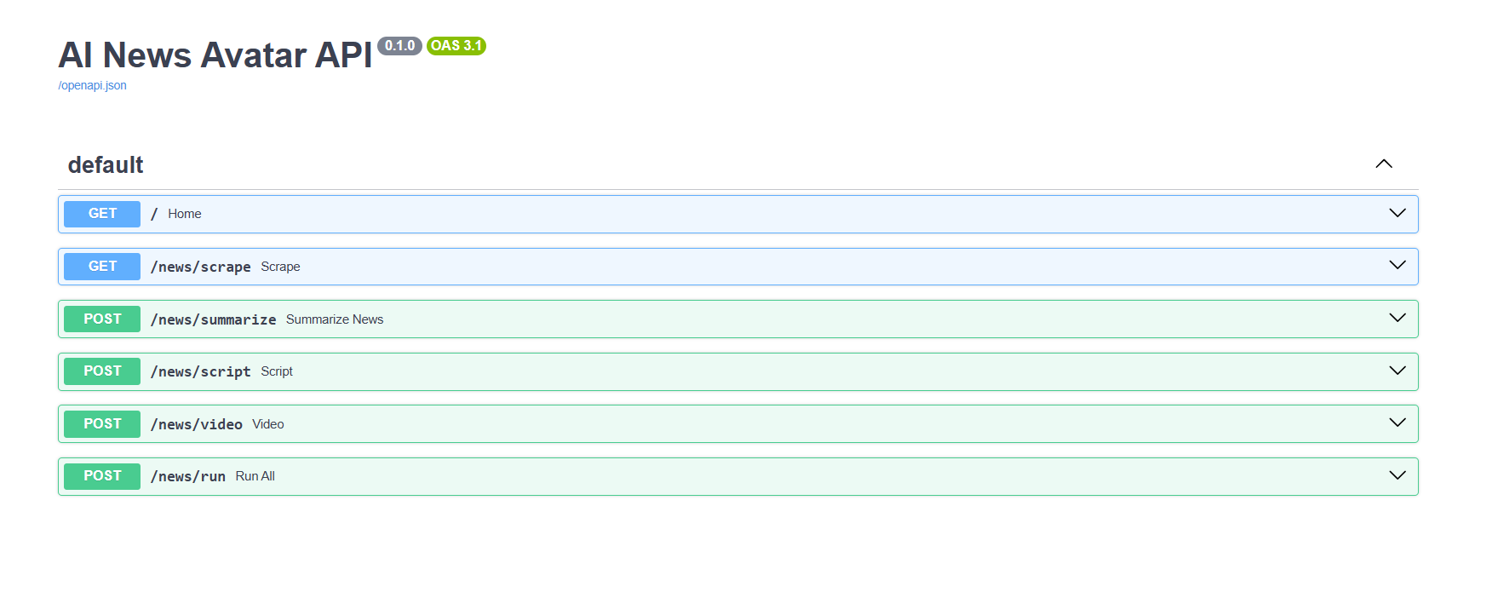
The API design supports asynchronous workflows and is compatible with background job queues for future scaling.

    - Setup & Execution
Requirements
Language: Python 3.10+
API: FastAPI
Scraping: newspaper3k
LLM: OpenAI
Avatar Video: Any third-party REST API(D-ID)
Installation
pip install -r requirements.txt
Environment Variables
OPENAI_API_KEY=your_key_here
DID_API_KEY=your_key_here
Run Server
uvicorn main:app --reload

- Codebase Structure
ai_news_avatar/
├── app/
│ ├── main.py # Entry point: FastAPI application and route definitions
│ ├── config.py # Environment variables (API Keys, Base URLs, Settings)
│ ├── models.py # Pydantic schemas for API requests and responses
│ └── services/ # Core logic layer
│ ├── scraper.py # Logic for extracting news from external URLs
│ ├── llm.py # Interface for Summarization (OpenAI/Gemini/Llama)
│ ├── script_writer.py # Logic to convert summaries into anchor-style scripts
│ ├── avatar.py # 3rd-party API integration for video synthesis
│ └── storage.py # Local file handling for JSON data and media
├── data/ # Intermediate data persistence
│ ├── articles.json # Raw scraped data (Title, Text, URL)
│ ├── summaries.json # Processed LLM summaries
│ └── script.txt # Final formatted news-anchor script
├── outputs/ # Final media delivery
│ └── video.mp4 # Generated AI Avatar video file
├── requirements.txt # Project dependencies (FastAPI, BeautifulSoup, etc.)
└── README.md # Comprehensive project documentation Each module has a single
responsibility, improving readability, maintainability, and extensibility.

- Outcome & Conclusion
This project successfully demonstrates a complete AI-driven media pipeline, transforming unstructured web news into a polished, avatar-based video broadcast. It showcases:
- Practical LLM prompt engineering
- Real-world API orchestration
- Asynchronous processing patterns
- Clean backend architecture
- Production-ready system design
The system confirms the feasibility of automated AI news broadcasting and provides a strong foundation for further enhancements such as multilingual support, real-time updates, and live agent interaction.

